The Eiffel Tower of Geomags™

How many Geomags will it take to recreate the Eifel tower?

# Approach: Be like water…

Seeing as how the Eiffel tower is such an irregular shape, it would be best to simplify the solution and focus on the raw material. If the wrought iron were to be melted down, it would it would fill the square base, 125 meters (410 ft) on each side, to a depth of only 6.25 cm (2.46 in) assuming the density of the metal to be 7.8 tons per cubic meter. (Harriss 1975). Using those dimensions, the volume for the melted tower would equal about 97.66 cubic meters.

Knowing this my approach would be to calculate the total amount of Geomags that would be equal to 97.66 cubic meters.

# Geomag™ Volume & Piece Count

## assumptions

* The measurements found in the Geomag Wiki are assumed to be accurate. (see below)
* Only the rod and sphere components will be taken into consideration.
* A configuration using 2d triangular lattices will be use across the entire structure. (see below)
* For uniformity, all calculations will be done in meters.

Geomag measurements (Horton 2007)

|  |  |  |
| --- | --- | --- |
| Rod Caliper length | 27.00mm | Distance between the extreme outer edges of the bar |
| Sphere Diameter | 12.70mm | Note that this unit conversion is exact |
| Geometric Distance | 38.84mm | Distance between centers of spheres |
| Dimple Depth | 0.43mm | Depth that sphere impinges past end of rod |

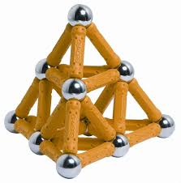

## Geomag Rods

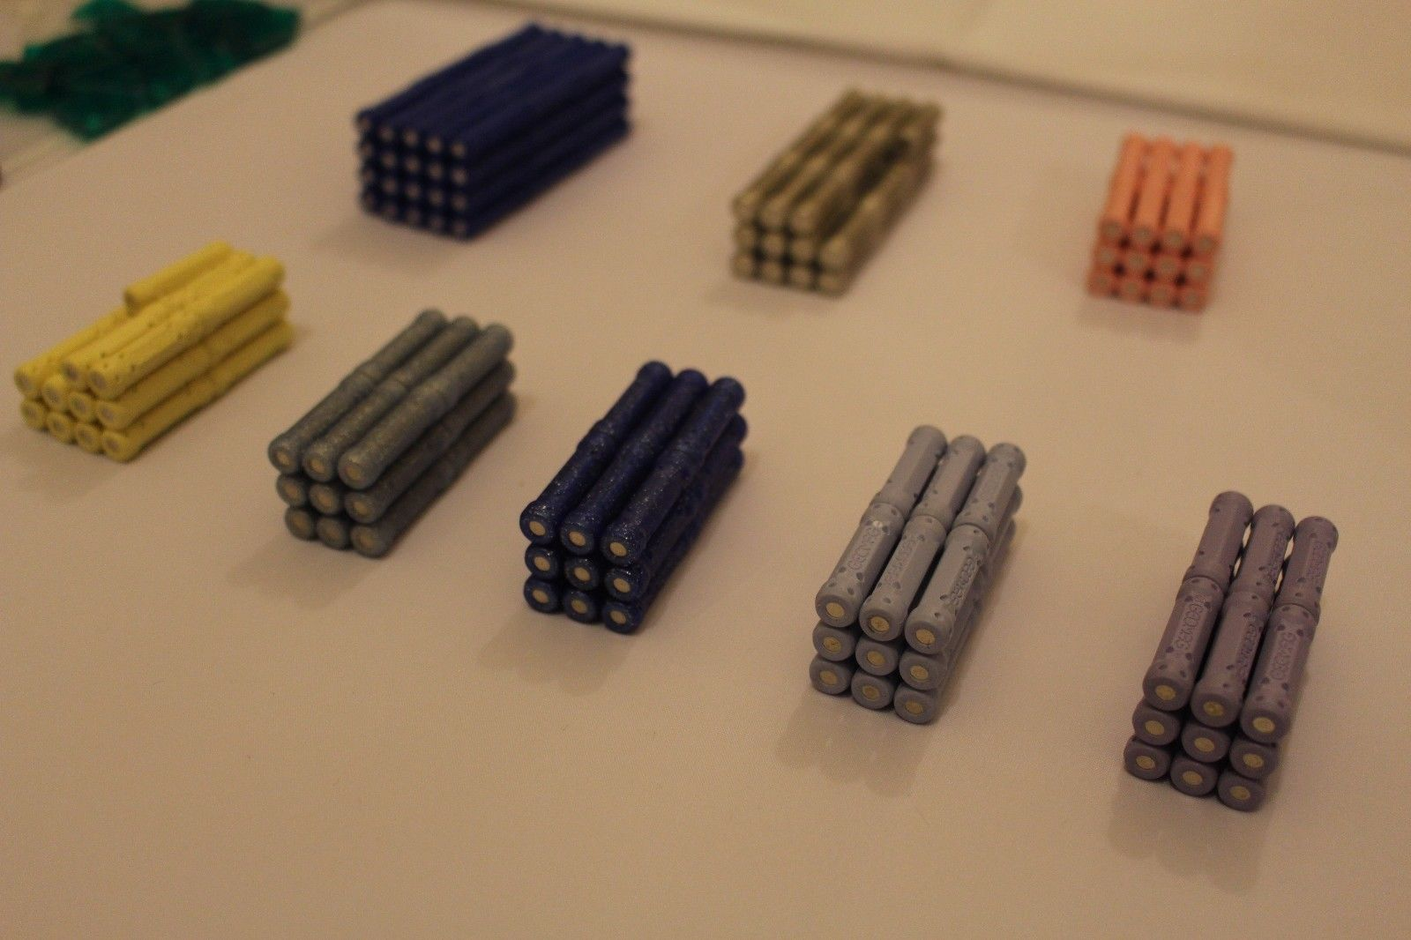

In order to get the volume of the rod, the shape would need to be broken down into parts.

1. Overall shape is equal to a cylinder.
$${Volume}_{cylinder}= πr^{2}h=π*\left(({0.00625 meters)}^{2}\right)*\left(0.027 meters\right)= 1.16 e^{-6} m^{3}$$

2. Spherical cap on each end where the spheres would rest.
$${Volume}_{spherical cap}= \frac{πh}{6}(3r^{2}+h^{2})$$

$${Volume}_{spherical cap}= \frac{π* .00043 meters}{6}(3{*(0.0037 meters) }^{2}+{(0.00043 meters)}^{2})$$

$${Volume}_{spherical cap}= 2.07 e^{-9}m^{3}$$

3. Volume of the cylinder minus the spherical caps.

$${Volume}_{Geomag Rod}={Volume}_{cylinder}- (2*{Volume}_{spherical cap})$$

$${Volume}_{Geomag Rod}=1.16 e^{-6} m^{3}- (2*2.07 e^{-9}m^{3})$$

$${Volume}_{Geomag Rod}=1.16 e^{-6} m^{3}$$

## Geomag sphere

The sphere is a little more straightforward.

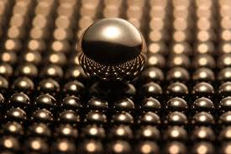 ${Volume}_{Geomag sphere}= \frac{4}{3}πr^{3}$

$${Volume}_{Geomag sphere}= \frac{4}{3}π{(0.00635 meters)}^{3}$$

$${Volume}_{Geomag sphere}= 1.07xe^{-6}m^{3}$$

## Rod to Sphere Ratio

Given the assumption that a Triangular 2d lattice will be used, the ratio of rod to sphere is 3:1. Each triangle will need 3 rods and 3 spheres but each sphere is shared amongst six triangles and each rod is shared between 2 triangles. (Horton 2007)

## Piece count computation

The general formula will be as follows:

Where: $X=number of Rods to be used$& $Y=number of Spheres to be used$

$${{(X*Volume}_{Geomag Rod})+(Y* Volume}_{Geomag sphere})= {Volume}_{Eiffel Tower}$$

Since we know that the ratio of rods to spheres is 3:1, we can include the following relationship:

$$X= 3Y$$

Using systems of equations we can update the initial formula and solve for both X and Y.

$${{(3Y*Volume}_{Geomag Rod})+(Y* Volume}_{Geomag sphere})= {Volume}_{Eiffel Tower}$$

$${{Y((3* Volume}_{Geomag Rod})+ Volume}_{Geomag sphere})= {Volume}_{Eiffel Tower}$$

$$Y\left((3*1.16 e^{-6} m^{3})+\left( 1.07xe^{-6}m^{3}\right)\right)= 97.66m^{3}$$

$$Y= \frac{97.66m^{3}}{\left((3*1.16 e^{-6} m^{3})+\left( 1.07xe^{-6}m^{3}\right)\right)}$$

$$Y= 21,504,215.88 ≅21,504,215 Geomag Spheres$$

$$X=3Y$$

$$X= 3*21,504,215.88=64,512,647.65 ≅ 64,512,647 Geomag Rods$$

# Works Cited

Harriss, Joseph. *The Eiffel Tower: Symbol of An Age.* London: Paul Elek, 1975.

Horton, Karl. *Geomag Weights and Measures.* May 2, 2007. http://geomag.wikia.com/wiki/Geomag_Weights_and_Measures (accessed March 19, 2018).